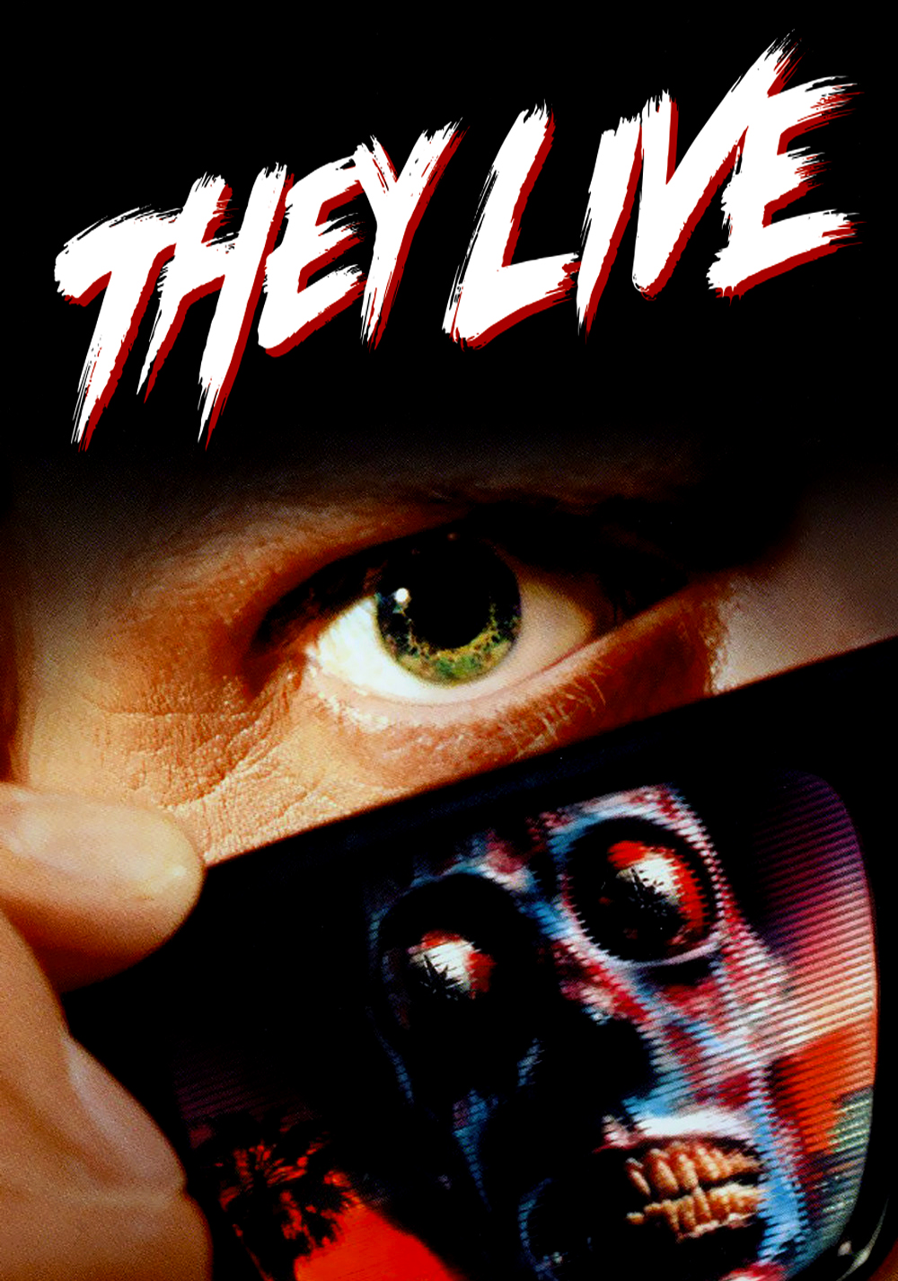

***Design by Kevin Atkins***

***29/11/18***

***Ages 12 and up***

***Ship date: Right now***

***THE SUPER OFFICIAL BOARD GAME***

**Game Story Summary:**

THEY LIVE takes place in the late 1980’s. Aliens have invaded and Hypnotised the entire population! The players find themselves in possession of SUPER SHADES, the only tool that shows the world in its true form, an alien conglomerate. Players must work together across three phases to fight back and fund the resistance to lead a hostile takeover! Be warned, too much exposure to hypnotisation may cause to turn heel and join the Aliens. Once funds are completed, the humans must race to the designated spot to destroy the Alien headquarters and free humanity from hypnotisation!

**Game Outline:**

As a Human, the player must traverse the map collecting cash to help fund the resistance against the Aliens.  
As an Alien, the player must stop the Humans from reaching their fund goal by strategically placing Hypno cards around the map while reducing their income.  
All players start in Phase 1 as Humans with the goal of gaining as much cash as possible. Players must avoid the pre-placed Hypno cards if possible while moving around through map. Once a player is hit too many times by Hypno cards, they switch sides and become an alien.  
Phase 2 begins at this point. Aliens must buy Hypno cards to stop the Humans from gaining more funds. Humans must do everything they can to continue gaining funds and fighting off the Alien threat.  
Phase 3 begins once the Humans have hit their cash goal. The alien must decide its Headquarters at the beginning of this phase. Once selected, the Humans must make their way to the Headquarters to win the game. This will prove difficult as the Alien now has a much easier chance to stop the Humans. The Aliens win once all players have been turned into Aliens.



**Character:**

All players begin as ordinary everyday humans, represented by pawns. Their lives are drastically changed upon receiving the mystical *Super Shades*, sunglasses that show the world in its true form. That true form being a planet enslaved by *Aliens!* It’s up to them to save the day and take out the Alien HQ by funding a resistance and fighting back. They must be careful though, as they too can be enslaved and turned against their companions.

All Alien players must turn heel in a most unexpected betrayal and fight against the Humans. Through the power of hypnotisation (and money) they must stop the Human resistance from raising enough funds to destroy the Alien headquarters. Turning other players to their side is the only way victory can be achieved, by any means necessary.

**Gameplay Overview:**

THEY LIVE: The Super Official Board Game is a table-top game

Setup consists of placing board tiles side by side to create the game map. Players then pick a character and place them anywhere on the board if no other player is already there. Two decks of cards are placed face down, one for ACTION cards and one for HYPNO cards. Players can decide turn order themselves but the default is whoever wore sunglasses most recently is the first to go. All players must now begin PHASE 1.

On a players turn they must roll a single four-sided die (D4). This decides how many spaces they can move that turn. Having now rolled, the player must choose a direction to move in. This can be up, down, left or right. For every space moved, the player gains $1, which is added to the human bank.

If the player hits the end of the map they must stop, regardless if they’ve only moved 2 of 4 spaces. If the player hits an A(ACTION) spot in PHASE 1 they must stop immediately and end their turn. If the player hits a H(HYPNO) spot they must immediately stop, add 1 point to their alien score, take a HYPNO card and do as it demands.

Once everyone has had a turn, a D4 is rolled to decide which player (1-4) is given a bonus Alien point. When a player reaches 4 Alien points, PHASE 2 begins.

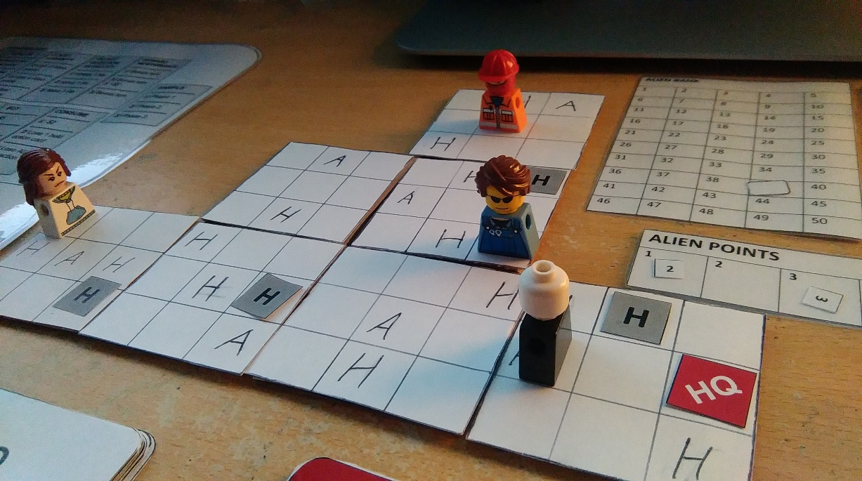

Close-up of game in play

There is now a player that has betrayed the rest and turned into an Alien. Their goal now is to use HYPNO cards to turn other players into Aliens. Once all players are turned, the Aliens win the game. Aliens behave similarly to Humans except that when taking a turn, they can decide to not move their pawn, but instead pay $5 to place a single bonus H spot on any unoccupied spot on the map. The Aliens have their own bank, which is decided at the start of PHASE 2 by rolling a D8 and adding on the current Human bank amount.

Humans must continue their funding with the same rules as prior except they do not have to roll a D4 at the end of each round for an extra Alien point. Alien points from the last round are kept, however the new limit for turning is 6 Alien points. A spots, once touched, now make the player draw an ACTION card. This only works for Humans and will simply stop an Alien in its tracks.

One thing that is also added is the ability for Player Versus Player interactions. This happens when a player, who’s turn it is, decides to move next to or pass by a player and initiate PVP. The two players must then roll a D6, whoever has the highest number wins. The winner gets 5$ for their team and can move the player 1 spot in any non-diagonal direction. If the opponent lands on a H or A spot the opponent must then take a respective card and follow the instructions. The loser must also subtract $5 from their bank. Humans can gain an advantage in PVP with the help of cards that increase their dice roll number.

If the Aliens successfully turn all Humans into Aliens at this point, the game ends. If Humans successfully reach $50, the game enters PHASE 3.

PHASE 3 follows the same rules as PHASE 2 for both teams. The main difference being that at the beginning of the round, the Aliens must place a HQ spot somewhere, unoccupied or not, on the map. This is the final goal for the Humans, who must race to it as fast as possible while they still live. Aliens must defend this spot while still trying to turn the Humans to the Alien side.

Once a Human has landed on the HQ spot or all people have become Aliens, the game is over.  
  
**Gameplay Experience:**

Much like many films and games do, John Carpenter’s THEY LIVE followed a 3 three act structure and I wanted to convey the feeling and intensity that comes with said act structure. The first phase is the slowest and involves the players learning how to function, move and raise money, not far off what the Film’s first act is like.

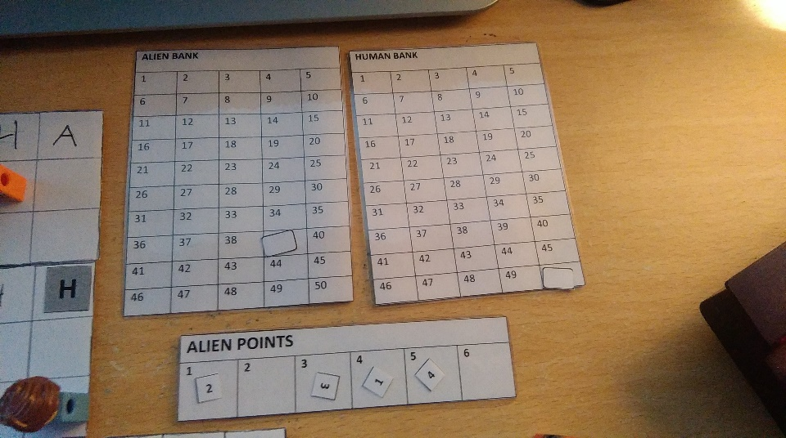The second phase is where things get interesting. A player is now the antagonist and must sabotage their friends. The concept of Aliens is introduced and the game now becomes a struggle for survival while also trying to fight back and raise money. Players at this point must think more strategically about their moves thanks to PVP being introduced alongside the ACTION cards, which can benefit or sabotage the players. For Humans, there is not just the threat of the game board itself but also the threat of the Alien. Alien points have been mildly increased to give the Humans some needed breathing space to help them cope with this newfound enemy, allowing for minor room for error. Smart players will try to initiate PVP when there is a chance of pushing the enemy into a H spot, resulting in possible alienation or long movements in an undesirable direction.

Score counters

The third and final phase is the highest in intensity, acting as the final big bang for players. If the Humans took too long to collect $50, the Alien points per person is dangerously close to turning them into Aliens. The intensity is incredibly high as it’s a make or break situation and requires heavy planning and tactics to make it to the HQ, which will naturally have been placed in a tricky spot if the Alien realises what’s happening, If there are more than one Alien, this phase is even trickier due to the number of enemies able to place hazards and initiate PVP.

**Mechanics and Modes:**

While the base game has a set player count of 4 players and one game-mode, the players are purposefully given up to 8 pawns with a customizable board, allowing for player made modes and rule sets.

The game has numerous mechanics that are easy to keep track of during intense situations. The main ones being PVP, Alien Points, Banks and the HYPNO/ACTION card decks.

PVP is initiated when a player moves alongside another player and wishes to attack. The resulting dice throw gains the winner money and a chance to move the loser 1 space in any direction. The loser withdraws money from their bank

Alien points are a counter that determines your alienation level. In the first phase, 4 Alien points is all it takes to turn you into the first Alien. From the second phase onward, 6 points are needed before you turn into an Alien. The points however do not reset per phase and must be managed carefully. These points are gained when you hit a H spot and during the end of round dice roll in the first phase.

Banks are counters of the collected money through the game. Human’s must raise their bank to $50 to reach PHASE 3. Aliens are given a bank upon the start of PHASE 2 and is decided by the Human bank plus a D8 roll. Aliens use their bank to pay for H spots to place around the map, forcing Humans into a trap and eventually turning them into an Alien. Both sides gain money for the bank by traversing the map.

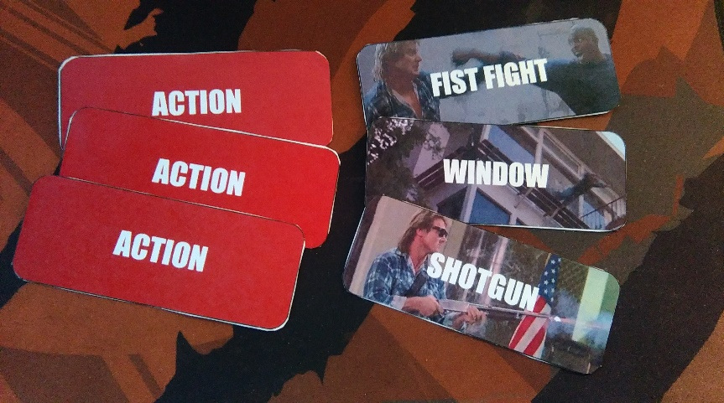ACTION cards and HYPNO cards are both beneficial and detrimental to the player that lands on them.  
ACTION cards have few drawbacks and can provide life saving tricks that can be held for later use. They can only be used by Humans however. Possible ACTION cards are the following:

ACTION card deck

* UZI –Use a D8 in your next PVP event. (HELD)
* SHOTGUN – Initiate PVP from any distance if opponent is on same row/column. (HELD)
* FISTFIGHT – Loser of next PVP fight misses their next turn. (HELD)
* WINDOW – Roll a D4 twice. First roll decides spaces moved. Second roll decides direction moved. 1=up 2=right 3=down 4=left
* NEGOTITION – Roll a D6. If you land a 6, Alien of choice is turned Human. (ONLY WORKS IF NOT THE ORIGINAL ALIEN) If there are no newer Aliens, do nothing.
* CAR RIDE – [PHASE 2] Move 2 spaces in any direction.  
   [PHASE 3] Move 4 spaces in any direction.

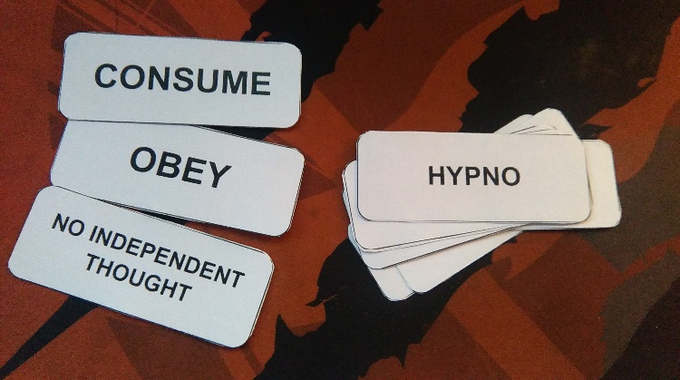  
HYPNO cards have many drawbacks and cause you to gain 1 Alien point, however they can be used by both teams. The number of HYPNO cards is also larger than that of ACTION cards. All HYPNO cards change their severity depending on the current phase, meaning some cards can outright instantly alienate a player in the final phase or they could lose up to 2 turns. Possible HYPNO cards are the following:

HYPNO card deck

* OBEY – [PHASE 1] Gain $3

[PHASE 2] Alien takes bonus turn for you

[PHASE 3] Instant Alienation

* FOLLOW – [PHASE 1] Repeat last player move  
   [PHASE 2] Repeat last Alien move  
   [PHASE 3] Undo last move turn
* DOUBT HUMANITY – [PHASE 1] Gain 2 Alien points

[PHASE 2] Gain 4 Alien points

[PHASE 3] Instant Alienation

* DO NOT QUESTION AUTHORITY – [PHASE 1] Rotate 1 tile  
   [PHASE 2] Move 1 tile  
   [PHASE 3] Move 1 tile
* REWARD INDIFFERENCE – [PHASE 1] Bonus turn  
   [PHASE 2] Bonus turn & Gain $2  
   [PHASE 3] Bonus turn
* NO INDEPENDENT THOUGHT – [PHASE 1] +1 to last move roll  
   [PHASE 2] +2 to last move roll  
   [PHASE 3] +3 to last move roll
* SUBMIT – [PHASE 1] Lose turn  
   [PHASE 2] Lose turn & lose $2  
   [PHASE 3] Lose 2 turns
* MARRY AND REPRODUCE – [PHASE 1] Gain $5  
   [PHASE 2] Gain $15  
   [PHASE 3] Bonus turn
* BUY – [PHASE 1] Lose $5  
   [PHASE 2] Lose $15  
   [PHASE 3] Nothing happens!
* CONSUME – [PHASE 1] Lose $2  
   [PHASE 2] Lose 1 held ACTION card  
   [PHASE 3] Lose all held ACTION cards

**Enemies and Bosses**:

While there are no bosses, players on the opposing teams can be considered as enemies. Initially the only adversary the players face is the game board itself. Once players change sides, the players themselves become enemies.

**Expansions and Bonus Materials:**

Naturally, the film ‘THEY LIVE’ is a good companion to the game, despite its age rating. The pawns themselves mostly represent characters that appear throughout the film.

As stated earlier, 8 pawns are given to the players alongside a customizable board to allow for experimentation on different modes, game sizes and more. Possible expansion types could include new card types, new rules and new board shapes and sizes.

**Monetisation:**

The game is a board game so monetisation would be strictly limited to the default price of the game itself. If I had to put a price on the board game, I feel that $15-$20 would be an attractive price for the game.

**Design History:**

The game went through about 2 conceptual versions before becoming what it was today. While the two versions were never properly play-tested or physically produced, both had elements that carried over to the final game.

The first version was a card game that had no board. I liked the idea of using a regular deck of cards alongside custom made cards that represented the billboards in the film (OBEY, CONSUME, etc). I liked the idea because it took a familiar setting but introduced a new element to change things up. This could’ve been stretched into representing how the film features an everyday world visited by an alien element. The game would’ve consisted of a familiar game of cards (poker, go fish, etc) practically being invaded by this new deck of cards which influenced the game. They game would’ve been 1v1 with no clear Human or Alien side, just two strangers trying to beat the other.  
The idea lasted some time but was scrapped right before playtesting would begin. This was mostly due to a struggle I encountered when deciding what the new cards would actually *do*. It was difficult to make them have an impact that changed the game besides from just switching cards and shuffling decks, which ultimately didn’t seem interesting enough to warrant a full-blown game, but rather an expansion to an existing one.

The second version was a complete 180 in terms of style and presentation. While it did have the deck of ‘HYPNO’ cards, it was now a board game similar to that of Snakes & Ladders’. It was based around the film’s final act where the protagonist scales the Alien HQ in an attempt to destroy their radar dish. They player would scale multiple floors while attempting to reach the top while being influenced by the HYPNO cards, which could be landed on and used.  
This design didn’t last as long as the card game as it felt unoriginal. Despite this I did a playtest between 2 people and the results were lacking. The objective of this playtest was to see how players liked the HYPNO cards and see if they were affecting the game in a meaningful manner. The main thing I took from the playtest was that the game was monotonous. Both players felt that the game was a drag to play since most of it was repetitive. The HYPNO cards as a concept were well received but how they changed the game wasn’t drastic enough and did little to intensify the gameplay.

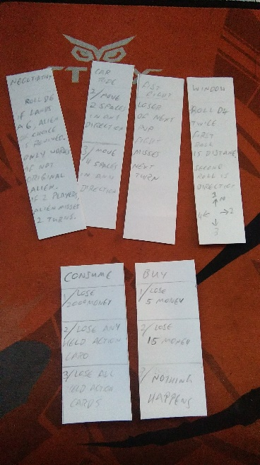The third and final version is what I have today. The idea of using pawns to traverse a map was still an element I wanted to use but I felt that the player should be able to influence where they wanted to go. The premade map also felt boring and meant that playing the game more meant that you would easily master it. I wanted new players to have as much chance of winning as old players. To do this I decided to use tile pieces that could be rearranged to allow the players to make their own map. Within each tile was 9 spots that a player could land on, each tile featuring 2-3 A/H spots.  
A spots were also introduced which were similar to HYPNO cards but would have more lenient outcomes.   
It was at this stage where I considered how players would be adversaries so I looked to the film itself for inspiration. One factor that the Aliens had in the film was the ability to hypnotise people to not just ignore them, but to indoctrinate others to their side. I felt this would be the best way to have players be adversaries, in that one would unwillingly have to backstab the other in order to win. This led to the introduction of Alien points, that were received when using a   
HYPNO card, which judged how indoctrinated you were. The first player to be  
 indoctrinated would be the Alien and the remaining Human player would be left   
to try and survive the rest of the game with a new adversary. I really liked this mechanic but I felt it would be wasted if just 1 person could be turned, so I decided to raise the player count from 2 to 4 players.  
Now I needed an objective for the teams. Aliens would obviously need to turn everyone else to their side. Humans on the other hand needed to do something that would act as the game’s main objective. I decided to make the main goal was for the Humans to traverse the map which would gain them money for every space they moved. This incentivised them to keep moving  
 but required them to watch out for H spots.  
At this point I needed something to make players interact with each-other. PVP was introduced to make players interact and offer some kind of reward for winning said interaction. Aliens were also granted the ability to buy H spots they could place, to strategically trick other players into entering them.  
Now that the mechanics were implemented, the game needed some form of 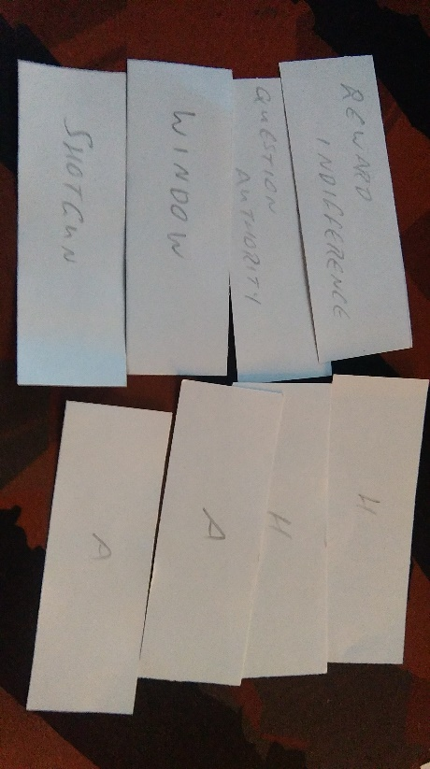pacing as at the time it was too simple and intensity remained at a constant rate. I once again looked to the film for inspiration on this and decided on a 3-phase structure, similar to a 3 act structure the film had. The game would be split into 3 phases, each one introducing a new mechanic. The first had all players as Humans collecting money. The second had an Alien introduced who would try place H spots and convert others to their side. The third and final phase would be the fastest, involving the remaining Humans rushing to the Alien HQ while close to being converted. This structure led to the game getting more intense as the game progressed, which was a parallel to the actual film.

Earliest version of HYPNO cards

Second variant of HYPNO cards that relied on rule book

With the game mechanics all ready, it was time for the first playtest session. The objective for this was to test out the game’s pacing and ensure that the tension was rising as the game progressed, while also ensure the mechanics worked as planned and were easy to understand.   
While the playtest took longer than expected with the whole match taking about 45 minutes. Setup took about 5 minutes, PHASE 1 took about 10 minutes, PHASE 2 took about 15 minutes and PHASE 3 took about 10 minutes. Players were visibly getting more interested as the game progressed and were being more strategical in their movements in later stages. The main points taken from the first playtest session was that players needed some way to keep track of the bank funds/Alien points besides using an external calculator and paper. Players were also unsatisfied with the current PVP rules as they felt there was no real benefit to triggering it. Some rules could also use more clarification in the rule book. Aside from these three complaints, the playtest went very well.

To fix the issues players had with the current version, I first made changes to PVP. While it was triggered the same, the outcome was made slightly more severe, with the loser losing $5 instead of $2 and the winner gaining $5 instead of $2. Previously the winner could move the loser 1 space in any direction and that was it. Now if the winner places the loser onto a H/A spot, the loser must use a respective card and obey its orders, gaining an Alien point if they’re Human. I also produced score counters for both Human and Alien banks along side a small counter for Alien points. The rule book was also slightly edited to have more clarification. I also added an extra page with visual examples of how some mechanics worked.

**Statement of Learning:**

One valuable lesson I learned from making this game is the process of iteration that a project can go through over the course of its development. The final version of the game was a complete 180 of what the initial concept was. Despite this it still shared key elements from all of its abandoned concepts. All 3 designs revolved around the use of HYPNO cards as they played a key role in the game’s structure. The second and final concept of the game involved moving pawns around board and involved Aliens vs Humans.

The second valuable lesson I learned was about MDA and how important it is to involve in game design. The Mechanics are how the rules are designed, the Dynamics are how the rules are followed by players and the Aesthetics are the resulting effect the Dynamics have on players.  
My main aim of the game was to have tension increase exponentially as the game. The rules and mechanics of the game purposefully try to manipulate players into feeling the tension rise as the game progresses. The rules give the Aliens more power overtime, while the Humans are more vulnerable to alienation. The chances of victory reduce the longer the game goes on and instils tension into the players. The combination of mechanics, rules and players leads to a successful artificially made thrill for the players.

The final thing I learned was the playtesting process and how to conduct a playtest successfully. The process of watching multiple players testing my game was an interesting one. Having to time each process and be as silent as possible was interesting and really helped with fine tuning the game to its current state. The balancing of mechanics and clarity of instructions was fine tuned to be as fair as possible. Had I not been able to playtest the game I would have had an unbalanced game that wouldn’t perform as well with a group of people.

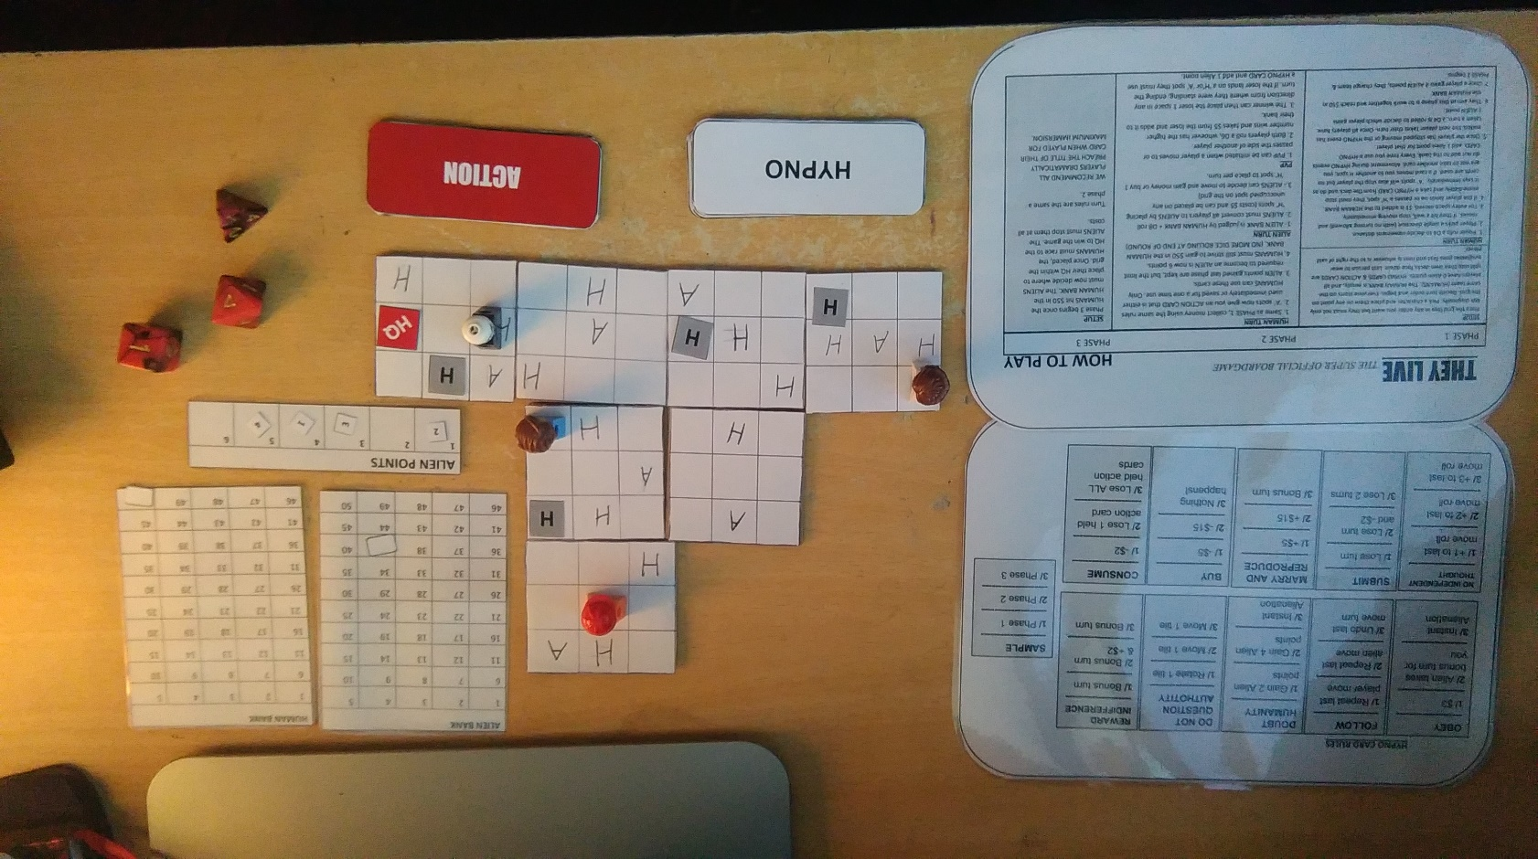

Final version of the game in play